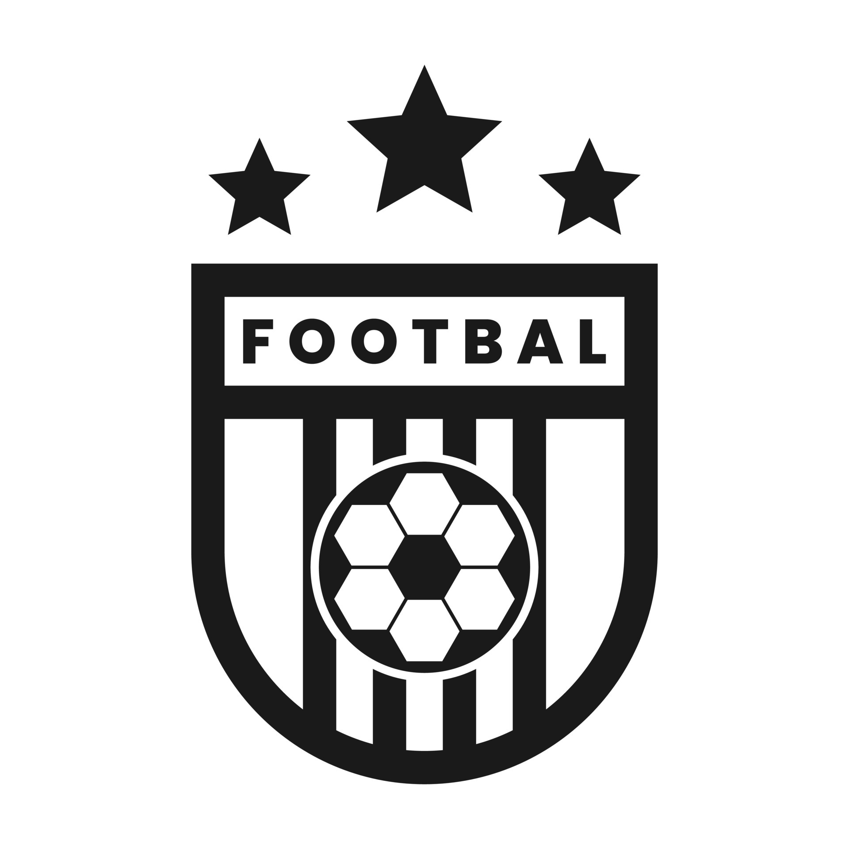

Equality, Diversity, and Inclusion Policy
Deal Town FC

Implementation Date: | 23/07/2024
Agreed By: | Club Board
Next Review Date: | 23/07/2024

Club Statement
Deal Town FC are fully committed to providing an inclusive and welcoming environment for everyone who wishes to be involved in the Club. We believe that every person who engages with the Club has a right to be treated fairly, with dignity and respect, irrespective of their personal characteristics. The Club is therefore committed to avoiding and eliminating discrimination of any kind in the Club and will under no circumstances condone unlawful discriminatory practices. The Club takes a zero-tolerance approach to discrimination, harassment, victimisation, bullying and abuse and endorses the principle of equality, valuing diversity and inclusion and combating unfair treatment throughout its organisation, supporters, and staff.

Equality Statement
The Club is committed to and endorses the principle of equality and strives to ensure that everyone who wishes to be involved in the Club and its activities whether as a supporter, player, the local community, customer, community outreach participant, employee, Board member, contractor, volunteer, partner, or supplier:

- Can be assured of an environment in which their rights, dignity and individual worth are respected, and in particular that they are able to enjoy their engagement at the Club without the threat of intimidation, victimisation, harassment, bullying and abuse; and
- Have a genuine and equal opportunity to participate to the full extent of their own ambitions and abilities, without regard to their age, disability, gender reassignment, marital or civil partnership status, pregnancy or maternity, race, religion and belief, sex, or sexual orientation.
Our aim is to embed equality across all levels of the Club. Through this Policy, the Club aims to ensure that the message of equality is followed and actively practised.

Legal Obligation
The Club is committed to avoiding and eliminating discrimination of any kind in the Club and recognises that it is unlawful to discriminate directly or indirectly because of an individual’s:
- age,
- disability,
- gender reassignment,
- race,
- religion or belief,
- sex,
- sexual orientation,
- marriage or civil partnership,
- pregnancy or maternity.

Individuals will be protected if they have a protected characteristic, are assumed to have a protected characteristic, are associated with someone who has a protected characteristic or with someone who is assumed to have a protected characteristic.

We are fully committed to compliance with all relevant equality legislation, this includes the Equality Act 2010.

The `Club`
The term `club` refers to Deal Town FC (all teams).

The Club commitment includes, but is not limited to:
- Having a culture of zero-tolerance on abuse, unlawful discrimination, bullying, misogyny, harassment and victimisation
- Dealing with complaints of abuse, unlawful discrimination, bullying, harassment, and victimisation seriously and timeously
- Monitoring recruitment and selection methods
- Providing equal opportunities
- Challenging unconscious bias
- Developing policies and procedures to ensure they do not discriminate unlawfully because of any of the protected characteristics.
- Monitoring the make-up of the workforce regarding protected characteristics to encourage equality, diversity, and inclusion.
- Ensuring all activities promote positive equality, diversity, and inclusion.

Each member of staff and volunteers are expected to adhere to this policy and procedure to ensure that a positive equal, diverse and inclusive opportunities climate exist.

Equality, Diversity and Inclusion Definitions:

Equality - Is ensuring individuals or groups of individuals are not treated differently or less favourably, based on their specific protected characteristic.

Diversity - Is about recognising differences. It is acknowledging the benefit of having a range of perspectives in decision-making and the workforce being representative of the club’s customers.
Inclusion - Is where people’s differences are valued and used to enable everyone to thrive at the club. An inclusive working environment is one in which everyone feels that they belong without having to conform, that their contribution matters and they can perform to their full potential, no matter their background, identity or circumstances. An inclusive workplace has fair policies and practices in the place and enables a diverse range of people to work together effectively.

Types of Discrimination:
An individual may experience different forms of discrimination. Discrimination may take the form of:

- Direct discrimination – this occurs when someone is treated less favourably than another person because of a protected characteristic they have.

- Indirect discrimination – this occurs when a condition, rule, policy or practice applies to everyone but particularly disadvantages people who share a protected characteristic.

- Discrimination by association - this is direct discrimination against someone because they associate with another person who possesses a protected characteristic.

- Discrimination by perception - this is direct discrimination against someone because an individual believes that another individual possesses a particular protected characteristic when they do not have that protected characteristic.

- Victimisation – this occurs when someone is treated less favourably because of making or supporting a complaint about discrimination, such as being denied a training opportunity or a promotion because they made/supported a complaint or raised a grievance under the Equality Act 2010, or because they are suspected of doing so.

- Harassment – this is where there is unwanted conduct, related to one of the protected characteristics (other than marriage and civil partnership, and pregnancy and maternity) that has the purpose or effect of violating a person's dignity; or creating an intimidating, hostile, degrading, humiliating or offensive environment. It does not matter whether or not this effect was intended by the person responsible for the conduct.

- Bullying – this is a form of personal harassment involving the misuse of power, influence or position to persistently criticise, humiliate or undermine an individual.

Failure to make reasonable adjustments this is where a physical feature or a provision, criterion or practice puts a disabled person at a substantial disadvantage compared with someone who does not have that protected characteristic and the employer has failed to make reasonable adjustments to enable the disabled person to overcome the disadvantage.

Complaints and Compliance:

The Club consider all forms of discriminatory behaviour, including (but not limited to) behaviour described in the Legal Obligations section of this Policy as unacceptable, and is concerned with
ensuring individuals feel able to raise any bona fide grievance, report or complaint related to such behaviour without fear of being penalised for doing so.

Appropriate sanctions will be taken against any Executive Board member, staff, player, match day fan, participant in outreach programmes and other people engaged with the Club’s activities who violate this Equality Policy.

Any individual who believes that they have been treated in a way that they consider to be in breach of this Policy by any other Club representative should in the first instance, and if they feel able to do so try and discuss it with that person. If that does not resolve the matter, or in the case of allegations against the Club itself, the individual may raise the matter with their manager, a staff member or the Club Welfare Officer / Safeguarding Officer.

Unfair Treatment:
All staff and volunteers should understand they, as well as their employer, can be held liable for acts of bullying, harassment, victimisation and unlawful discrimination to fellow employees, volunteers, customers, suppliers, and the public.

Reasonable Adjustments
To ensure practices remain justifiable and lawful the Club will aim to make the necessary reasonable adjustments relating to all protected characteristics. This includes, but is not limited to, physical features and environmental adjustments in relation to any of its premises ensuring fairness and equality for potential employees, current employees and third-party contractors associated with the Club.

The Club will take all reasonably practicable steps to ensure staff are able to participate in its business activities on an equal basis. You are encouraged to tell the Club if you need appropriate support/reasonable adjustments so that this can be provided.

Recruitment and Selection
The Club aims to ensure that job applicants do not suffer unlawful discrimination. Recruitment procedures are reviewed regularly, in line with the Equality Act 2010 and Safer Recruitment Guidelines, including but not limited to, to ensure that individuals are treated based on their relevant merits and abilities.

Job selection criteria is regularly reviewed to ensure that they are relevant to the job and are not disproportionate. Shortlisting of applicants is undertaken by more than one person. Job advertisements will avoid stereotyping or using wording that may discourage groups with a protected characteristic from applying.

Applicants will not be asked questions about health or disability before a job offer is made unless those questions are permitted by law, for example, to establish whether reasonable adjustments might be required for an interview or other selection process, or for equal opportunities monitoring.

The Club requests equality and diversity data from all applicants on a voluntary basis when applying for a position and will regularly review shortlisting as the recruitment process progresses. The information is kept in an anonymised format and retained solely within the Human Resources department. The data is used to support the Club to take appropriate steps to avoid discrimination and improve equality, diversity and inclusion.

The Club is required by law to ensure that all employees are entitled to work in the UK. Assumptions about immigration status will not be made based on appearance or apparent nationality. All prospective employees, regardless of nationality, must be able to produce original documents before employment starts, to satisfy current immigration and right to work legislation.

Training, promotion and terms and conditions
Employees will be given appropriate access to promotions and training to enable them to progress. All decisions will be made based on merit, ability and job suitability coupled with transparent and justifiable methods.

Workforce composition and promotions will be monitored to ensure equality of opportunity at all levels of the Club. Where appropriate, steps will be taken to identify and remove unjustified barriers and to meet the needs of disadvantaged or underrepresented groups.

Terms and conditions, benefits and facilities will be reviewed regularly to ensure that they are available to all staff who should have access to them and that there are no unlawful obstacles to accessing them.

Responsibility and Key Contacts
The board of directors has overall responsibility for the effective operation of this policy and for ensuring compliance with equality legislation. Day-to-day operational responsibility has been delegated to the Human Resources Department.

All Managers must set an appropriate standard of behaviour, leading by example and ensuring that those they manage adhere to this Policy and Procedure. Managers will be given appropriate training on equal opportunities awareness and equal opportunities recruitment and selection best practice.

Associated Policies:
Whistleblowing Policy
Anti Bullying Policy

